19CSE401 - Compiler Design

Lab Sheet 3

S Abhishek

AM.EN.U4CSE19147

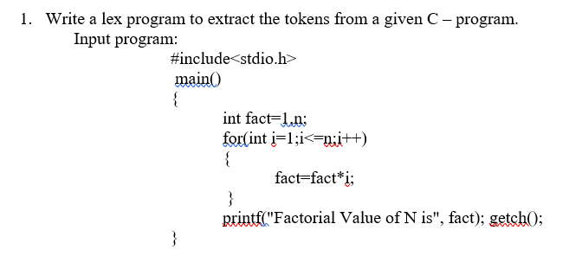

1.l

%option noyywrap

%{

    #include <stdlib.h>

    #include <stdio.h>

%}

String ["](.)+["]

Number [0-9]+

Identifier [a-z]([a-z]|[0-9])\*

%%

"#include<stdio.h>" printf("<INCLUDE, %s>",  yytext);

"(" printf("<LBRACKET>");

")" printf("<RBRACKET>");

"++" printf("<INC>");

"=" printf("<ASSIGN>");

";" printf("<SEMI>");

"<=" printf("<LE>");

"{" printf("<LPAREN>");

"}" printf("<RPAREN>");

"\*" printf("<MULT>");

"," printf("<COMMA>");

"int" printf("<INT>");

"for" printf("<FOR>");

{Identifier} printf("<ID,%s>", yytext);

{Number} printf("<NUM,%s>", yytext);

{String} printf("<STRING>");

%%

*int* main()

{

    FILE \*f;

    f=fopen("Input.txt","r");

    yyin=f;

    yylex();

    return 1;

}

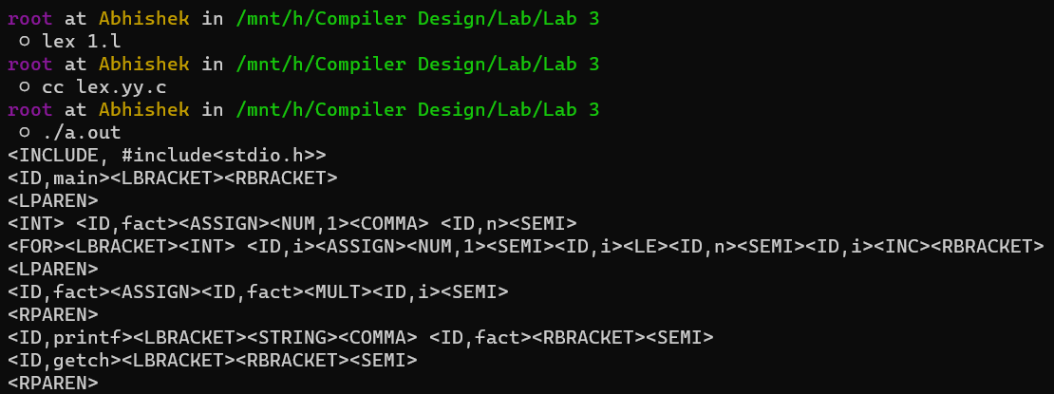

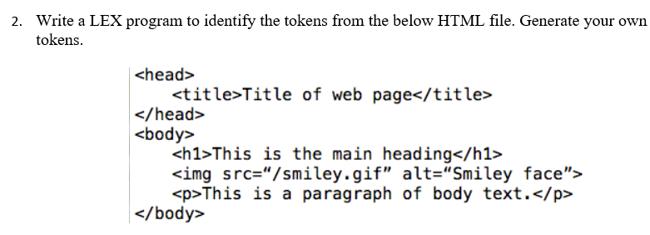

Input.html

<!DOCTYPE html>

<html>

    <head>

        <title>Page Title</title>

    </head>

    <body>

        <h1>This is a Heading</h1>

        <p>The HTML<code>button</code> tag defines a clickable button.</p>

        <p>The CSS <code>background-color</code> property defines the background color of an element.</p>

    </body>

</html>

2.l

%option noyywrap

%{

    #include<stdio.h>

%}

Tag <[^>]\*>

%%

{Tag} printf("%s", yytext);

\n printf("\n");

. "";

%%

int main()

{

    FILE \* f;

    f=fopen("Input.html","r");

    yyin=f;

    yylex();

    return 0;

}

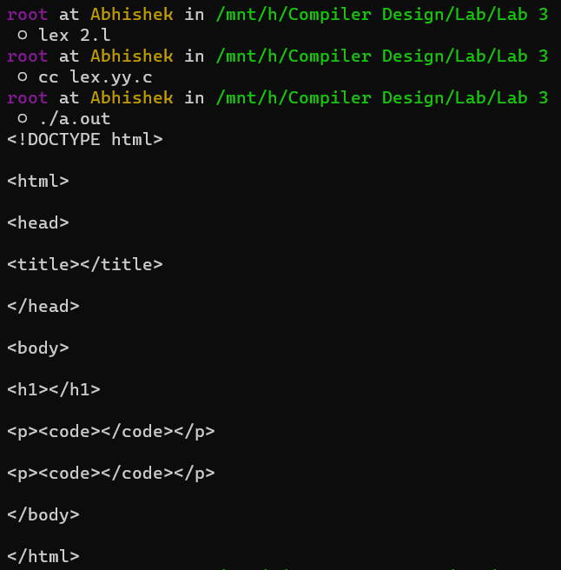

Thankyou!!